MAJOR PROJECT 2:

#Face ditection with Live stream

import cv2

faceCascade = cv2.CascadeClassifier('haarcascade_frontalface_default.xml')

eyeCascade = cv2.CascadeClassifier('haarcascade_eye.xml')

video_capture = cv2.VideoCapture(0)

while True:

# Capture frame-by-frame

ret, frame = video_capture.read()

gray = cv2.cvtColor(frame, cv2.COLOR_BGR2GRAY)

faces = faceCascade.detectMultiScale( gray, 1.1, 5)

# Draw a rectangle around the faces

for (x, y, w, h) in faces:

cv2.rectangle(frame, (x, y), (x+w, y+h), (0, 255, 0), 2)

#EYE CLASSIFIER

roi_gray = gray[y:y+w, x:x+w]

roi_color = frame[y:y+w, x:x+w]

eyes = eyeCascade.detectMultiScale(roi_gray, 1.3, 5)

for (ex, ey, ew, eh) in eyes:

cv2.rectangle(roi_color, (ex, ey), (ex + ew, ey + eh), (255, 0, 0), 2)

# Display the resulting frame

cv2.imshow('Face ditection with Live stream', frame)

if cv2.waitKey(1) == ord('q'):

break

# When everything is done, release the capture

video_capture.release()

cv2.destroyAllWindows()

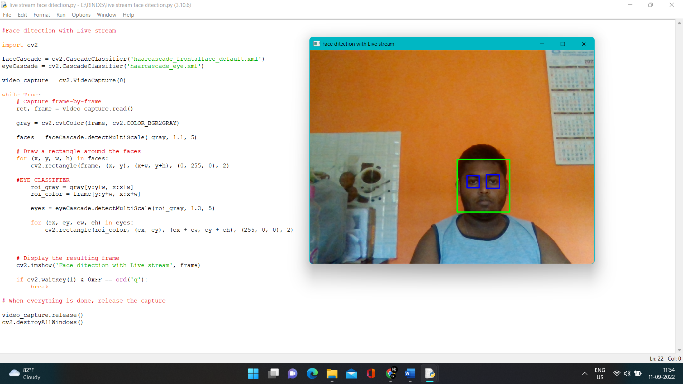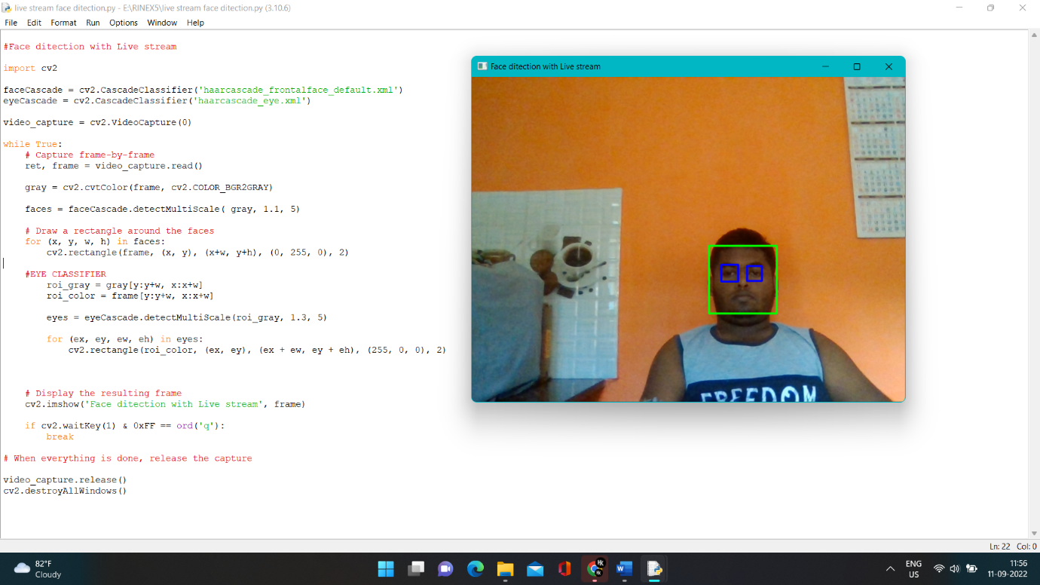OUTPUT of the above code :